PROJECT REPORT — EXPENSE TRACKER

Project Title: TO-DO List
Internship: DecodeLabs Internship Program
Submitted By: _Hiba Rani

Course: Internship

Submitted To: DecodeLabs

Submission Date: 15-4-2026

Title
Expense Tracker System using Python

1. Introduction
The Expense Tracker is a Python-based application designed to help users record and manage daily expenses. It allows continuous input of expenses and calculates the total expenditure using real-time processing.

2. Objectives
- To track daily expenses efficiently
- To implement accumulator logic
- To understand loops and input handling
- To apply IPO (Input-Process-Output) model

3. Technologies Used
- Python
- Command Line Interface (CLI)

4. Features
- Add multiple expenses
- Continuous data entry
- Calculate total spending
- Exit option for user

5. Methodology (IPO Model)

Input:
- User enters expense amount

Process:
- Expense is added to total using accumulator

Output:
- Displays updated total expense

6. Code Explanation
- A variable total is used to store accumulated expenses
- A while loop is used for continuous input
- Input is converted into numeric form (float)
- Condition is used to exit program

7. Output
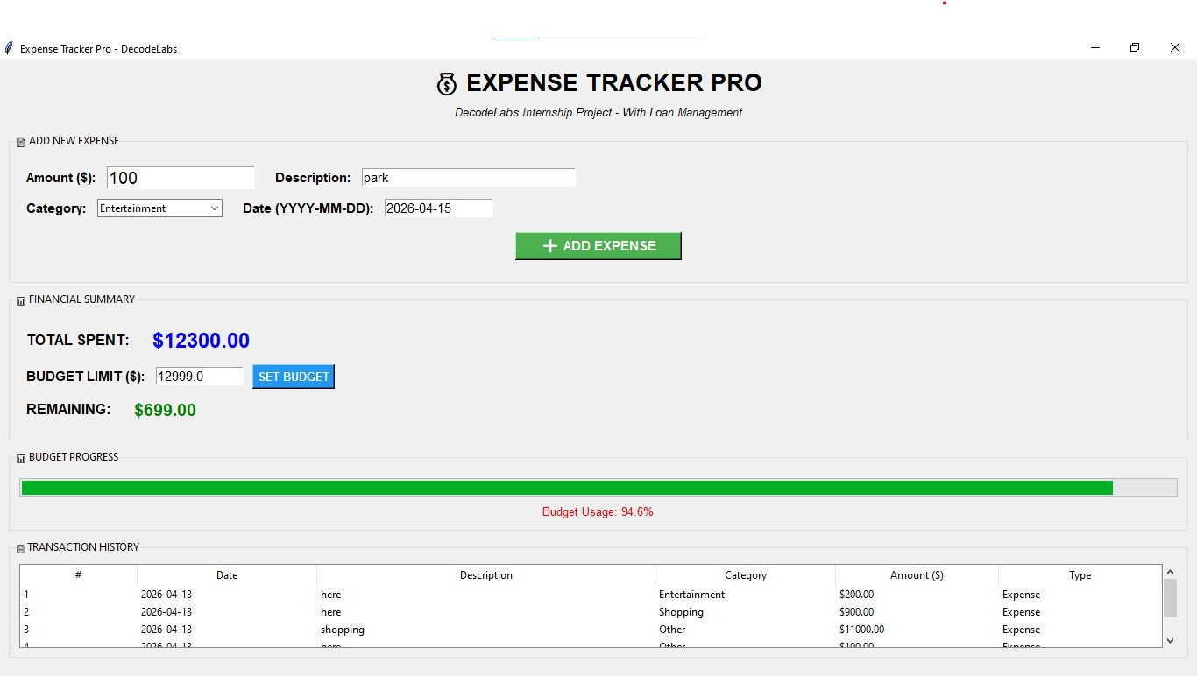

8. Conclusion
This project helped in understanding real-time data processing and accumulator patterns in Python.

“This project was developed as part of DecodeLabs Internship to strengthen practical programming skills.”

